1.Write a Pandas program to select distinct department id from employees file.

**Aim**

The aim of this program is to select distinct department IDs from an employees dataset using Pandas.

**Algorithm**

1. **Import Pandas**: Import the Pandas library to handle the data in a DataFrame.
2. **Create DataFrame**: Create a DataFrame using the provided data.
3. **Select Distinct Department IDs**: Use the unique method on the 'DEPARTMENT_ID' column to obtain distinct department IDs.
4. **Print Output**: Print the array of distinct department IDs.

**CODE**

import pandas as pd

data = {

'DEPARTMENT_ID': [10, 20, 30, 40, 50, 60, 70, 80, 90, 100, 110, 120, 130, 140, 150, 160, 170, 180, 190, 200, 210, 220, 230, 240, 250, 260, 270],

'DEPARTMENT_NAME': ['Administration', 'Marketing', 'Purchasing', 'Human Resources', 'Shipping', 'IT', 'Public Relations', 'Sales', 'Executive', 'Finance', 'Accounting', 'Treasury', 'Corporate Tax', 'Control And Credit', 'Shareholder Services', 'Benefits', 'Manufacturing', 'Construction', 'Contracting', 'Operations', 'IT Support', 'NOC', 'IT Helpdesk', 'Government Sales', 'Retail Sales', 'Recruiting', 'Payroll'],

'MANAGER_ID': [200, 201, 114, 203, 121, 103, 204, 145, 100, 108, 205, 0, 0, 0, 0, 0, 0, 0, 0, 0, 0, 0, 0, 0, 0, 0, 0],

'LOCATION_ID': [1700, 1800, 1700, 2400, 1500, 1400, 2700, 2500, 1700, 1700, 1700, 1700, 1700, 1700, 1700, 1700, 1700, 1700, 1700, 1700, 1700, 1700, 1700, 1700, 1700, 1700, 1700]

}

df = pd.DataFrame(data)

distinct_department_ids = df['DEPARTMENT_ID'].unique()

print(distinct_department_ids)

OUTPUT

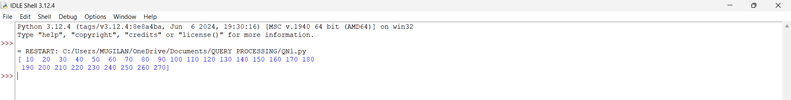

RESULT

The program successfully selects and prints the distinct department IDs from the employees dataset.